Code Smells detected in package Migration

- Shotgun Surgery:

In this package, the class /jabref/src/main/java/org/jabref/migrations/PreferancesMigrations.java has multiple strings with the same value. If there is a change of one string, it is inconvinient to search all the strings with the same value and change.

Possible Solution:
If possible, create constants, enumerators to store all the strings with the same value and/or functions to adapt the current solution.
Examples: Image 1 and 2.

- Feature Envy

In the previous class has functions that focus on manipulating data of other classe rather than itself.

Possible Solution:
Reduce the amount of method calls by moving the current methods implementations pr creating new methods inside each class.
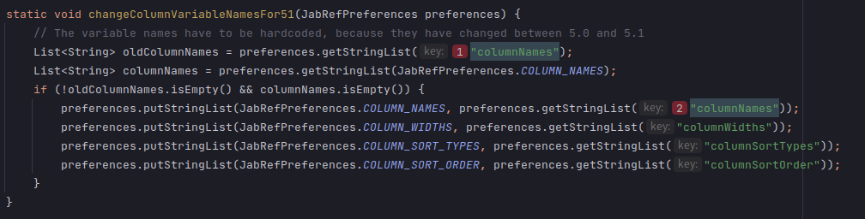
Examples: Image 1 and 2.
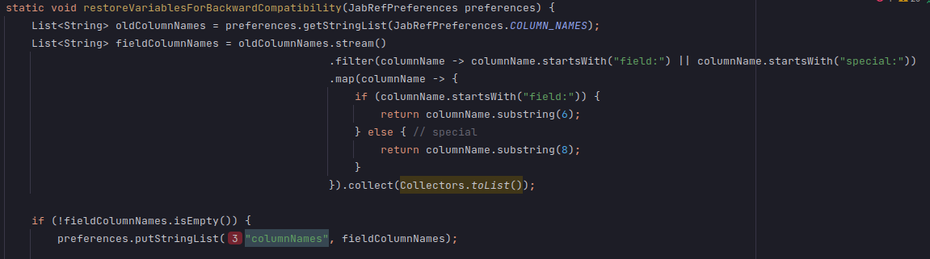
Image 1 and 2.

Innapropriate Intimacy
In the class /jabref/src/main/java/org/jabref/migrations/MergeReviewIntoCommentMigration.java has publics methods that calls and has access to private parts, such as variables and functions, of other classes.

Possible Solution:
Create new private functions that gets all the variables needed to the current method.
Example: Image 3

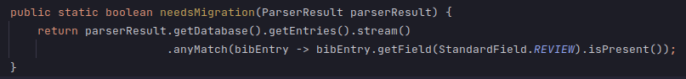
Image 3.

